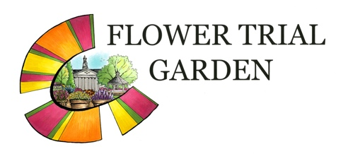

2024 ENTRY FORM
Colorado State University
Annual Flower Trial Garden
http://www.flowertrials.colostate.edu/

ENTRY FORM DUE BY JANUARY 15, 2024

IMPORTANT INFORMATION
Entry Form
Attached is an Excel Sheet CSU 2024 Trials Entry Form. Or visit the following link to download an Entry Form:
https://flowertrials.colostate.edu/contact-information/

**We prefer a DIGITAL COPY of your 2024 Entry Form.**
This can help to ensure accuracy and limit the potential for errors entering in hard copy forms.

There are TWO TABS on the Excel Document Spreadsheet.
Tab 1: “Fee Schedule”. This sheet should automatically calculate the fees for trial entries, based on entry type from the “EntryForm” Sheet.
Tab 2: “EntryForm”. This sheet is where you will enter specific trial entries and the information requested below.

On the “ENTRYFORM” tab spreadsheet, please carefully enter the following:
ENTRY NAME: Include Genus, specific epithet, variety/cultivar. **Please note any trademark or registrations
TRIALING CONDITIONS: Please check the appropriate box for the trialing conditions
TRIAL LOCATION: Planting location: Ground Bed; Container; or Both
GROWING LOCATION: Sun, Shade; or both
STATUS: If the variety is “new” for this year and you would like it designated as such, please indicate.
CULTURE: Indicate any PGR applications or other cultural aspects that should be followed.
General or Standard PGR Treatments
Geraniums: Standard treatment is to apply Cycocel® PGR twice, with about a 2-week interval between applications.
Petunias and Calibrachoas: Standard treatment is to apply B-9 with 0, 1 or 2 applications.
If no PGR treatment is specified for varieties included on the entry form, the standard treatment will be applied.
Pinching – Varieties will be pinched as needed for trial uniformity unless otherwise indicated.

CLASSIFICATIONS: Note any specific growth characteristics to align the entry into a particular group
OTHER COMMENTS or NOTES: Any additional concerns that we should be aware of for the entry.

Delivery Details and Dates:
DELIVERY ADDRESS: CSU Horticulture Center; 1707 Centre Avenue; Fort Collins, CO 80526

ALL SEED Varieties: DELIVER to CSU no later than January 15, 2024 (Week 3).
Sufficient seed should be supplied to obtain at least two 804 flats of plants.

ALL VEGETATIVE Varieties: DELIVER to CSU between April 8 and April 19, 2024. (Week 15/16).
Sufficient cuttings numbers required for each variety entered:
Ground Trial: at least 30 cuttings per variety
Container Trial: at least 10 cuttings per variety
Both Locations: at least 40 cuttings per variety

**Please Note**
We are unable to root cuttings at our University Greenhouses due to lack of propagation facilities and space. We request that trialers send rooted cuttings. If you cannot supply rooted cuttings, we can work with you to find a rooting station in Colorado.

Save your 2024 Entry Form Copy and return to Dr. Chad Miller
Email: chad.miller@colostate.edu

